**DFA in LEX code which accepts even number of zeros and even number of ones.**

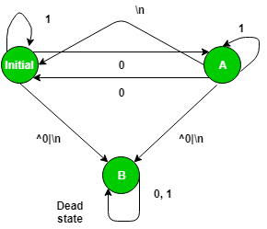

**Examples –**

Input : 1001

Output : Accepted

Input : hjabdba

Output : INVALID

LEX CODE:

%{

%}

%s A B

%%

<INITIAL>1 BEGIN INITIAL;

<INITIAL>0 BEGIN A;

<INITIAL>[^0|\n] BEGIN B;

<INITIAL>\n BEGIN INITIAL; printf("Accepted\n");

<A>1 BEGIN A;

<A>0 BEGIN INITIAL;

<A>[^0|\n] BEGIN B;

<A>\n BEGIN INITIAL; printf("Not Accepted\n");

<B>0 BEGIN B;

<B>1 BEGIN B;

<B>[^0|\n] BEGIN B;

<B>\n {BEGIN INITIAL; printf("INVALID\n");}

%%

void main()

{

yylex();

}